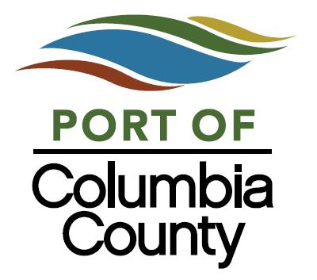

June 27, 2024

John Smith
xxxxxx
xxxx, OR 9705x

RE: Citation # 3686

Dear John,
A citation was issued to you on June 20, 2024, because there was no Day Use Ticket displayed in your vehicle on the dashboard. According to Port ordinance 2014-01, and in accordance with state law the $25.00 fine must be paid within 30 days of citation issue date. As of this date we have not received your payment.
Please note if you do not pay this within 30 days, by July 20, 2024, the fine may be increased to $250.00. You can mail a check to the address below or stop by our office at the address listed below to pay the fine. Since citation information is tracked, repeat offenders maybe banned from the marine park facilities.
If you have questions, contact the Port office at the number listed below. For your convenience we have enclosed a copy of the citation for your review.
Thank you,

Mary Laitala
Administrative Assistant
laitala@portofcolumbiacounty.org

Port of Columbia County
100 E Street
PO Box 190
Columbia City OR 97018
503-397-2888

Enclosure

